**PRACTICAL NO : 5**

AIM: Write programs to demonstrate inter process communication (IPC) using sockets, shared memory and/or pipes/message queues

**NAME : MAITHILI LOKHANDE**

**ROLL NO. : 07**

**BATCH : B1**

1. Implement reader writer problem using shared memory

**WRITER.c**

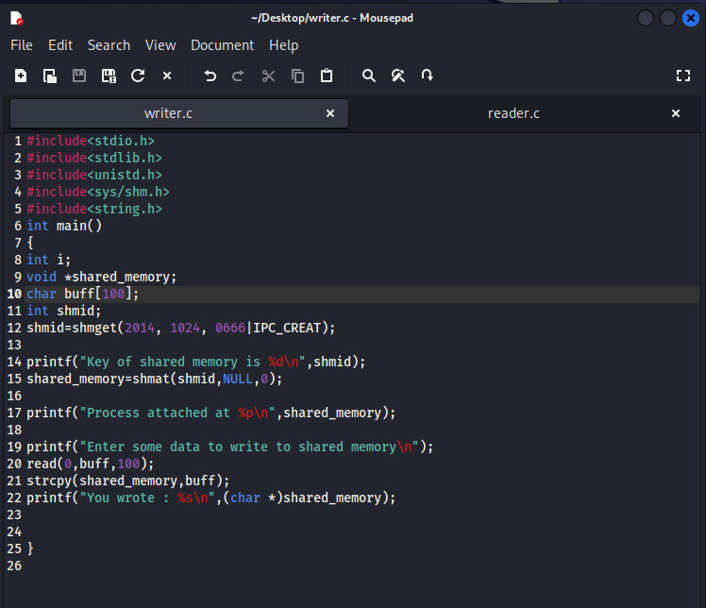

**READER.c**

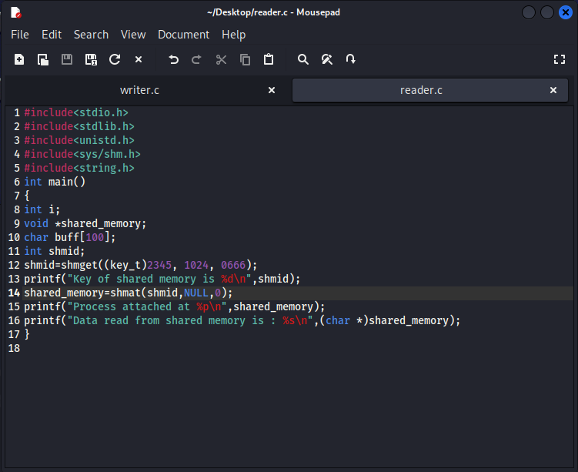

**OUTPUT :**

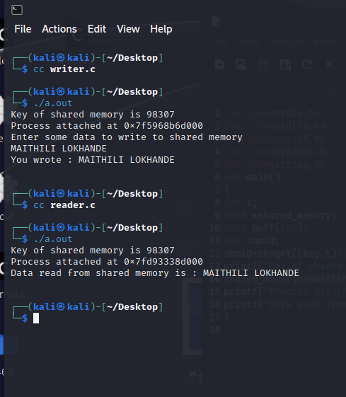

2. Implement IPC using pipe

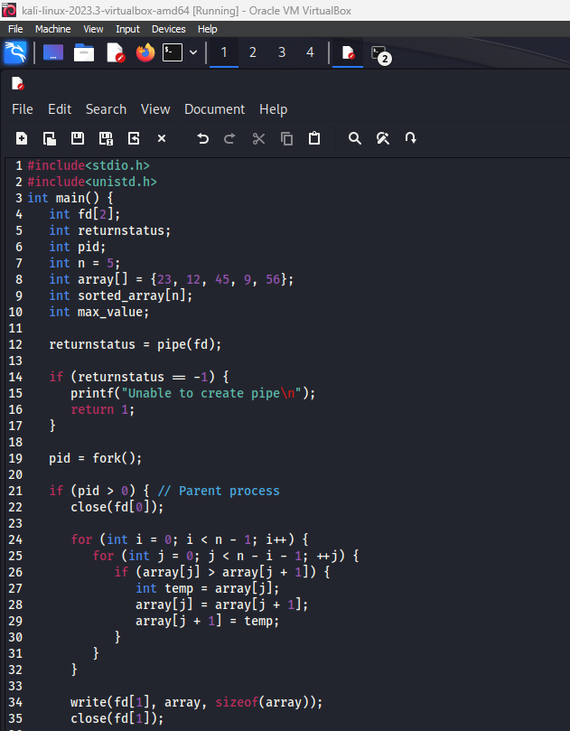

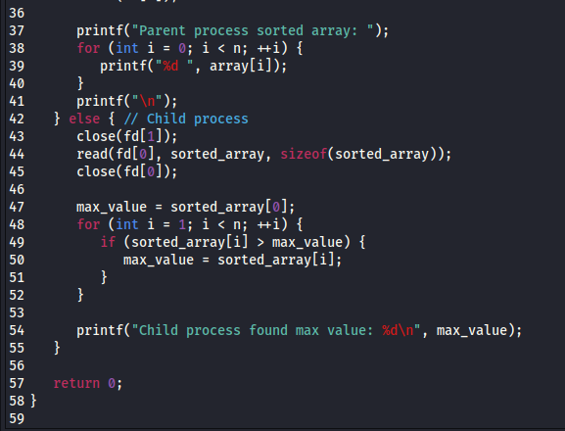

OUTPUT :

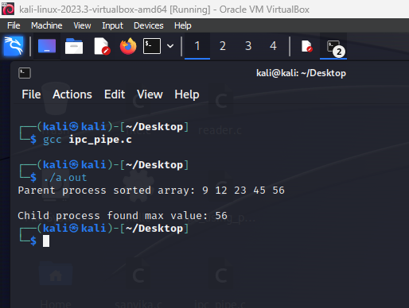

**PRACTICAL no: 6**

AIM: Write a program to implement Producer Consumer problem

**NAME: Maithili Lokhande**

**BATCH: B1**

**ROLL NO : 07**

**CODE:** 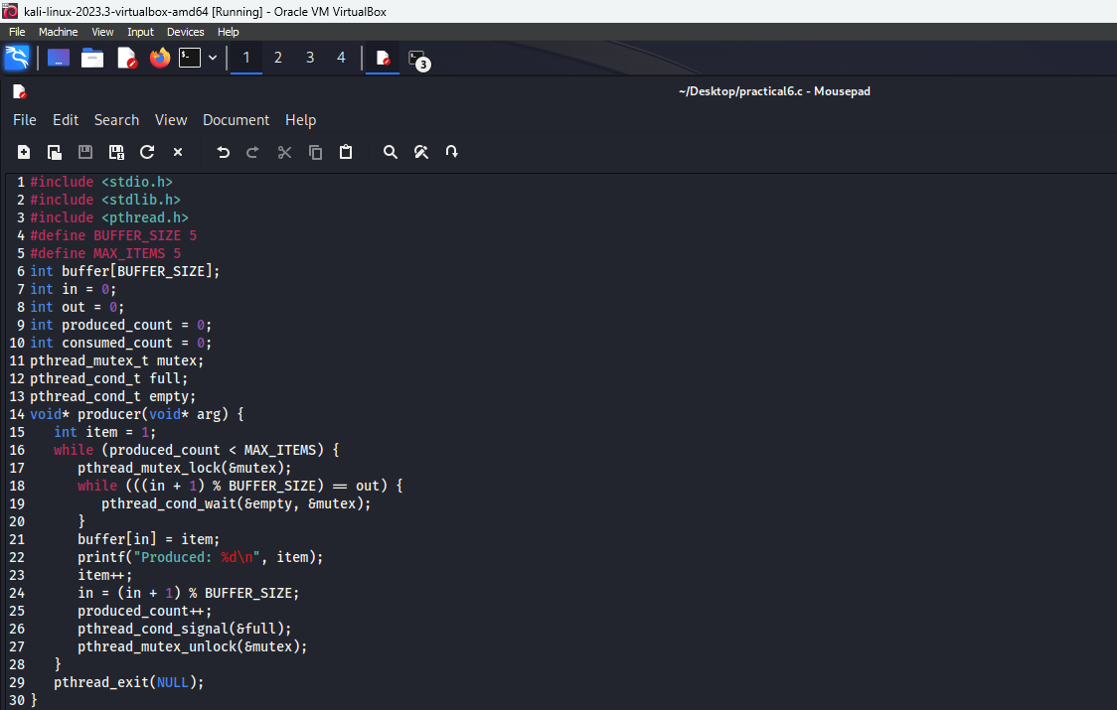

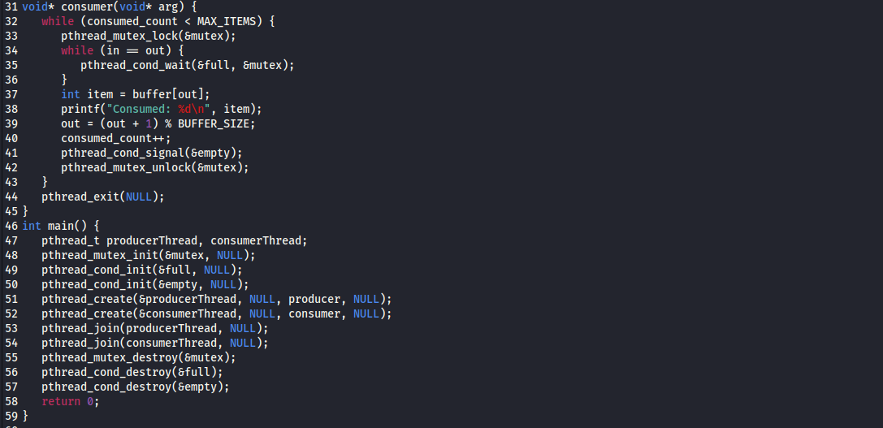

**OUTPUT:**

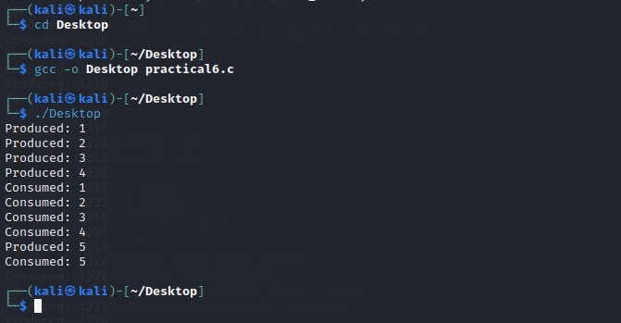

**PRACTICAL NO: 7**

AIM: Write a program to demonstrate the deadlock detection algorithm

**Name : Maithili Lokhande**

**Roll no. : 07**

**Batch : B1**

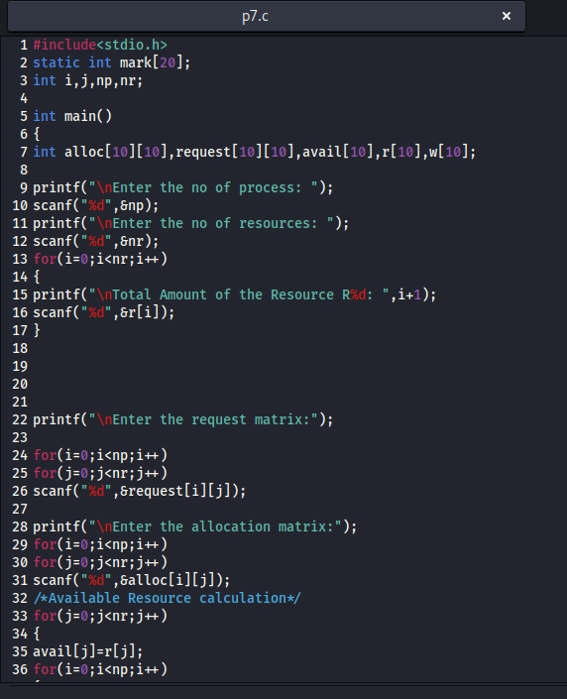

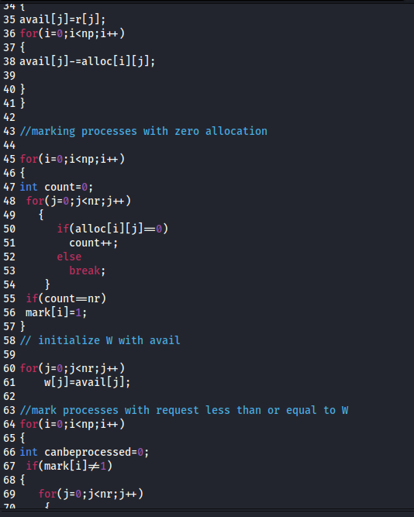

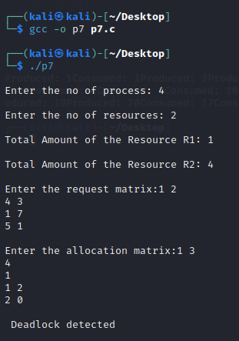

**Practical no: 8**

AIM: Write programs to implement different memory management schemes.

**NAME : Maithili Lokhande**

**ROLL NO : 07**

**BATCH : B1**

Output :

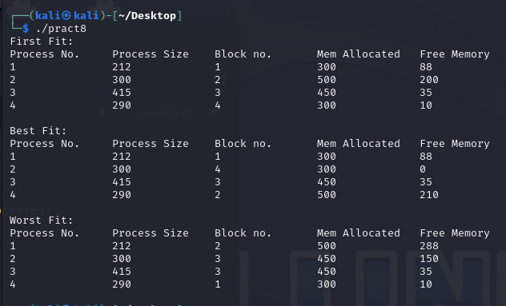

Code: 